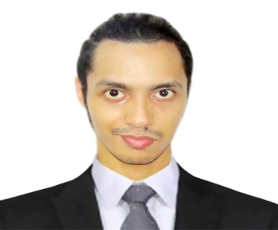

**RAFAEL MOHSIN R. SOLEDAD**

3507 C Lukban St. Tondo Manila

09216001812

RafaelMohsin_Soledad@yahoo.com

**OBJECTIVE**

It is my objective to excel in information technology and pursue my dreams to achieve my goal of success and prosperity. I am willing to start small in the field of information technology and I will work very hard to achieve efficiency.

**EDUCATION**

**TERTIARY**

**2013 – Present** **STI COLLEGE – CALOOCAN**

Bachelor of Science in Information Technology

**SECONDARY**

**2009 – 2013** **F.G CALDERON INTEGRATED HIGH SCHOOL**

High School Diploma

**SKILLS**

* Computer skills (MS Word, Powerpoint, Excel)
* Programming skills (PHP)

**EXTRA CURRICULAR ACTIVITY**

**2014** **SPELLING BEE**

STI COLLEGE – CALOOCAN

**CHARACTER REFERENCES**

Gabriel Entac

Quezon City Red Cross

Officer

09076193841

Natalia Cantillia

Bureau of Quarantine

Section Chief

09208232285

Diosdado Sapo

COMELEC

Chief Security Officer

09173311326